International conference
«Reliability and dynamics of heavy machines»
RDHM-2018
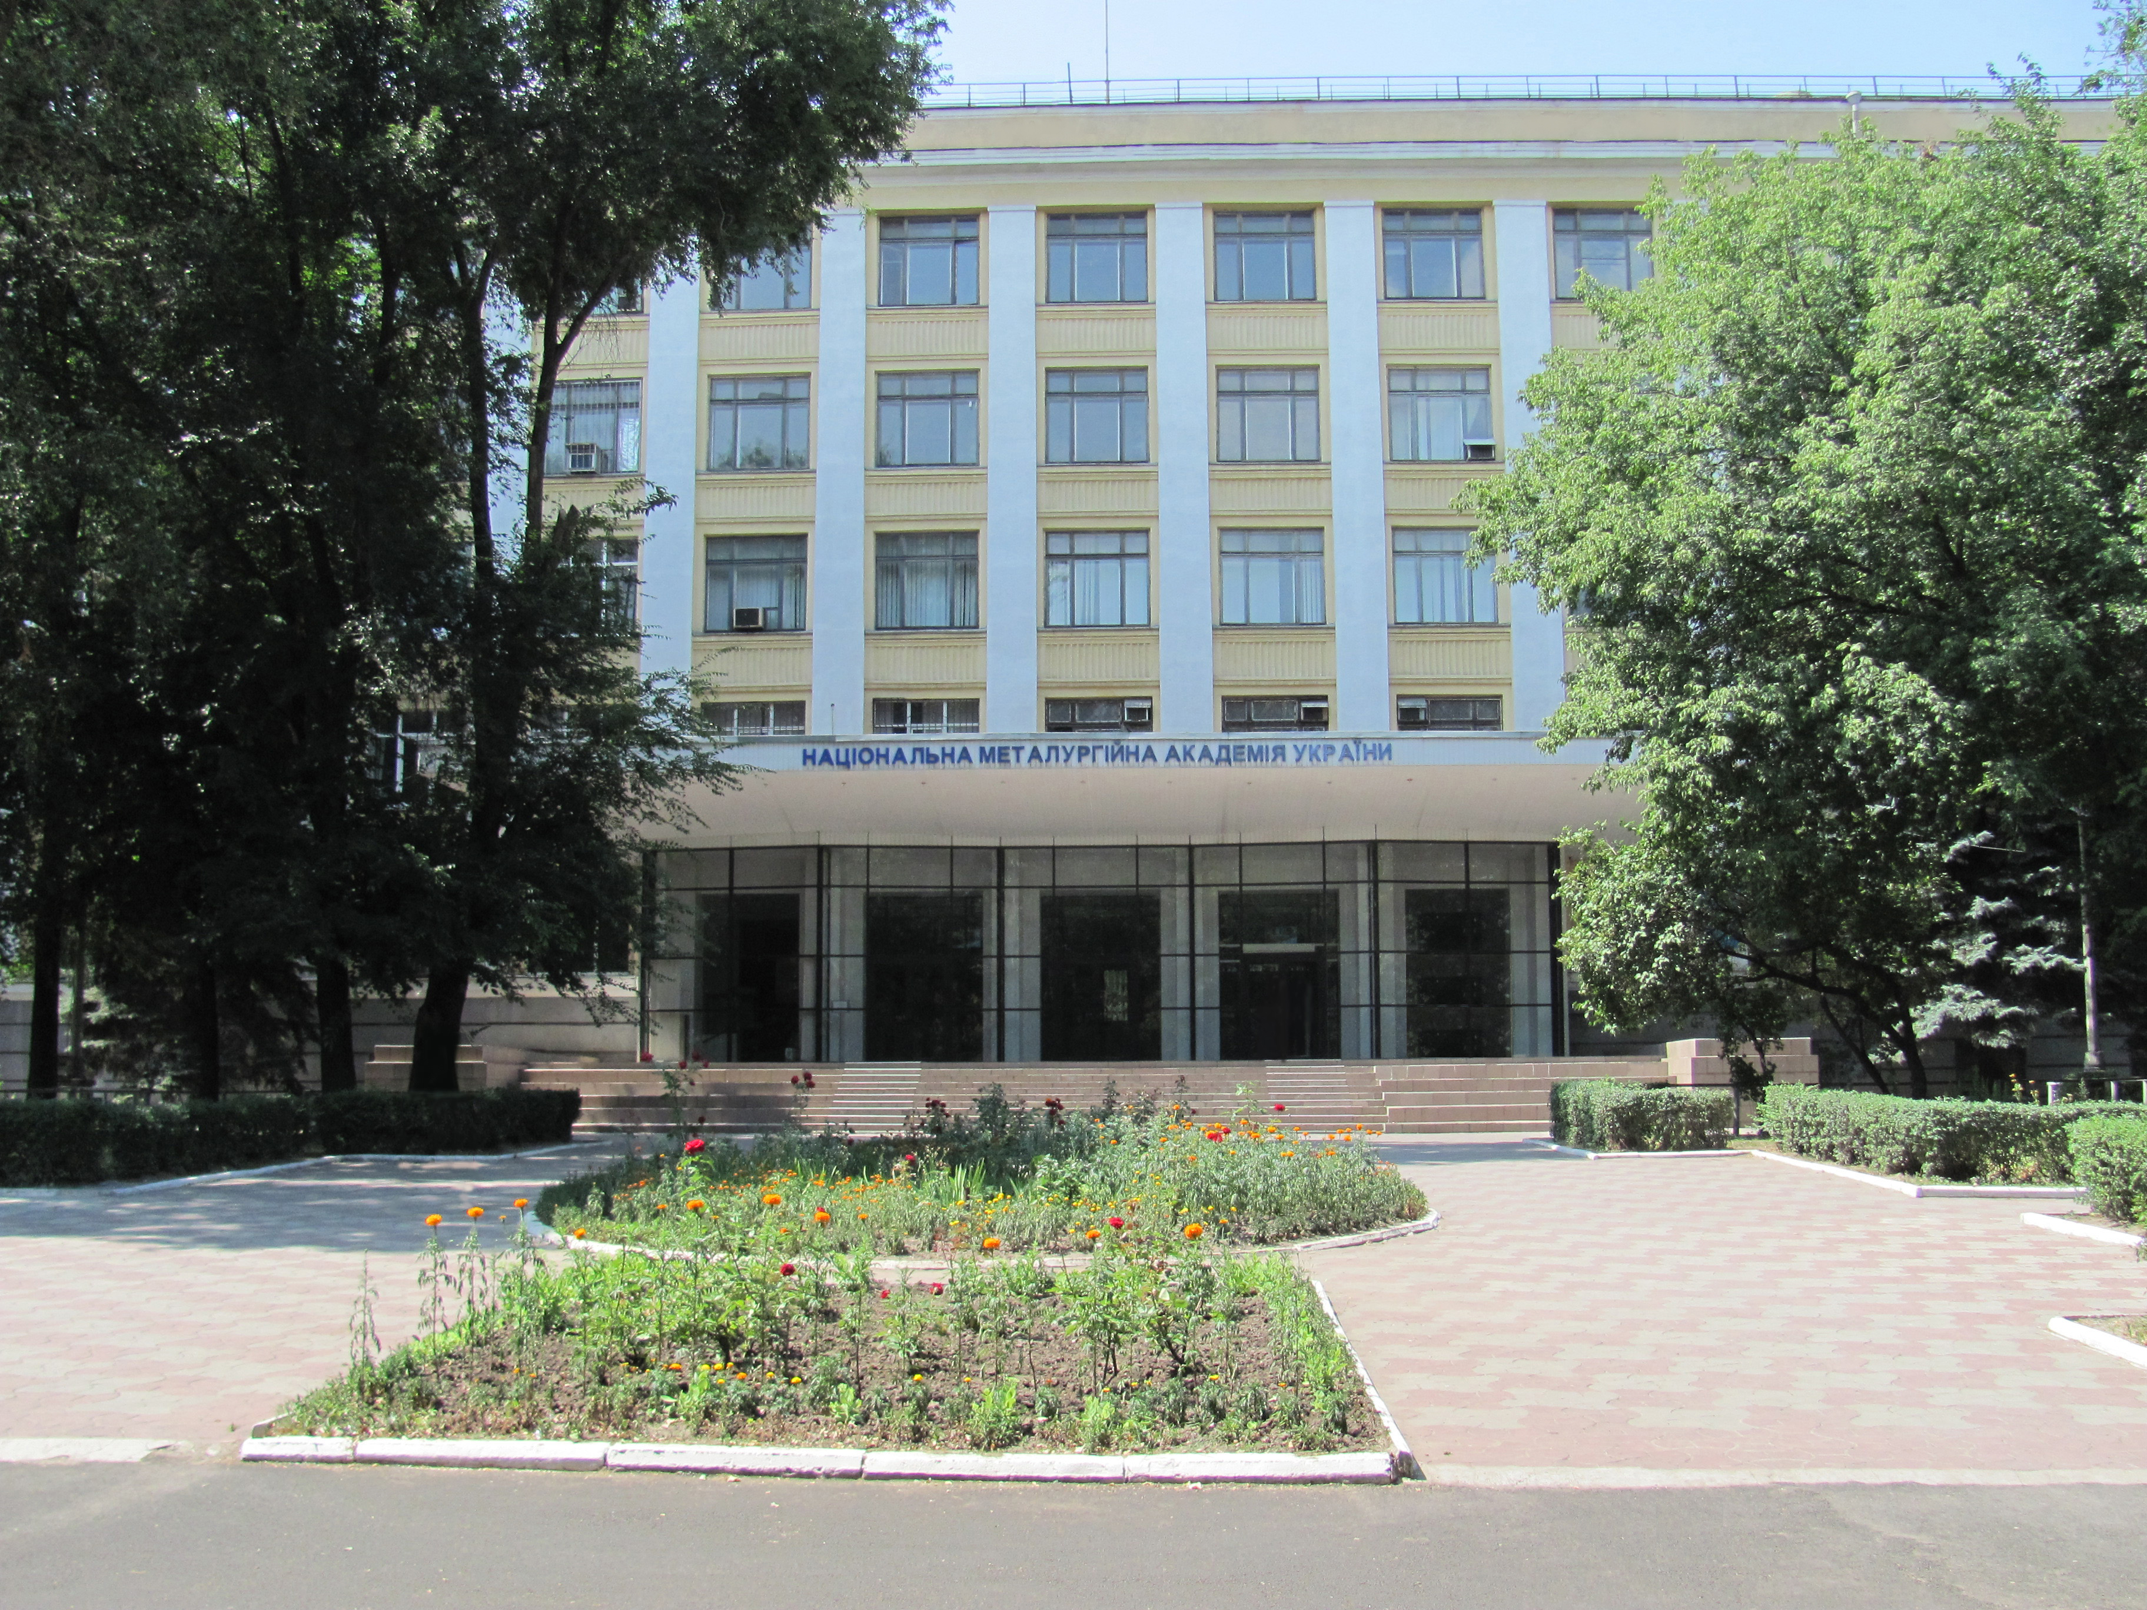

Dnipro, Ukraine
October, 30, 2018

Dedicated to the 80th anniversary
of academician of the NAS of Ukraine
Vadim I. Bol’shakov

Organizers

Ministry of education and sciences of Ukraine
National Metallurgical Academy of Ukraine

National Academy of Sciences of Ukraine
Z. I. Nekrasov Institute of Ferrous Metallurgy

Danieli Heavy Maсhinery Engineering

Information message

International conference «Reliability and dynamics of heavy machines» RDHM-2018 is conducted on October, 30 —November, 1, 2018 in the
National Metallurgical
Academy of Ukraine.

From 2013 this is the third conference organized by the organizers on this topic. At the conference it is planned to consider the connection of dynamic processes in heavy industrial and transport vehicles with their reliability; establish trends in the development of methods for dynamic analysis, evaluation of reliability and durability of mechanical systems.

Purpose of conference.
As a result of the conference the advanced directions of research in the field of reliability and dynamics of heavy machinery will be outlined, technical solutions for industry and transport in the field of diagnosing the technical condition of mechanical systems, as well as their maintenance and repair. Recommended methods of creating elements of structures with a guaranteed quality level will be outlined.

Academician V.I. Bol’shakov made a great contribution to solving the problems that the conference is devoted to. In particular, this concerns the problems of rolling mill dynamics, as well as the synthesis of charging systems for large blast furnaces.

Thematic of the conference:
- Section. Reliability of complex mechanical systems.
- Section. Dynamics and strength of mechanical systems.
- Section. Diagnostics and maintenance of heavy machinery.
- Section. Blast furnace charging systems.

PROGRAM COMMITTEE:
Chairman:
Corresponding member of NAS of Ukraine, rector of National Metallurgical Academy of Ukraine
Velichko A. G. (Dnipro, Ukraine)

Members of the committee:
Algin V.B. (Minsk, Belarus)
Brezinova J. (Košice, Slovakia)
Verenev V. V. (Dnipro, Ukraine)
Dobrov I.V. (Dnipro, Ukraine)
Ischenko A. A. (Mariupol, Ukraine)
Krampitz M. (Magdeburg, Germany)
Mamedov A.T. (Baku, Azerbaijan)
Maruschak P.O. (Ternopil, Ukraine)
Oginsky J. K. (Zaporizhia, Ukraine)
Prentkovskis O. (Vilnius,Lithuania)
Saliy D. (St. Ingbert-Rohrbach, Germany)
Scmidt R. (Magdeburg, Germany
Sladkowski A.(Katowice, Poland)
Tsibanyov G. V. (Kiev, Ukraine)
Uchitel A. D. (Krivoy Rog, Ukraine)

ORGANIZING COMMITTEE
Co-Chairman:
Belodedenko S. V. (Dnipro, NMetAU)
Muraviova I.G. (Dnipro, IFM)

Members of the committee:
BaglayA.V. (Kharkiv, Diamech-Ukraine)
Baluiev R. (Danieli Heavy Machinery Engineering)
Bilichenko G. N. (Dnipro, NMetAU)
Vlasov A. A. (Zaporizhia, ZGEA)
Kononov D. A. (Dnipro, NMetAU))
Koshik E. (Danieli Heavy Machinery Engineering)
Malich N. G. (Dnipro, NMetAU)
Pelyh I.V. (Dnipro, EVRAZ-DMP)
Chervinskiy A. E. (Dnipro, NMetAU)
Yunakov A. M. (Dnipro, IFM)
Scientific secretary: Ganush V. I. (Dnipro, NMetAU)
Workings languages of conference — Ukrainian, English.

Organizational fee: for participants from Ukraine - 500 UAH, for students and postgraduate students - 200 UAH; for the rest of the participants - 50 USD.

Control terms:
- Delivery of the first information message — by 10.03.2018
- Reception of requests — by 10.05.2018
- Delivery of the second information message — by 01.06.2018
- Payment of organizational fee and reception of reports — by 1.09.2018
- Delivery of invitations to a conference and programs — by 30.09.2018
- Opening of conference, presentation of reports — from 30.10.2018
The proceedings of the conference will certainly be issued prior to its opening, mainly in professional editions, wich are included in online scientometric
database.

The order of the papers, the address for the transfer of the registration fee will be given in the second message and on the conference page.

Request on participating in a conference is desirable to send to an electronic conference address
nadeznost2013@gmail.com

Address:
An international conference RDHM-2018, NMetAU, chair «Machines and units of metallurgical production», Gagarin av., 4, Dnіpro, 49005, Ukraine.

The organizational committee will be thankful you for spreading of this information among colleagues and interested persons.

For all problems apply to the conference secretariat:
Ganush V. I. Tel. +38 0562 47 22 45, +38 067 564 72 43
Web-page: https://nmetau.edu.ua/ua/mdiv/i2043
e-mail: kaf.mamp@metal.nmetau.edu.ua
nadeznost2013@gmail.com

(At sending of letter in a column «Theme» in is necessary to specify RDHM-2018).

Excursions are foreseen on the history-culture places of Pridneprov’ia region and on the leading enterprises of city in the program of conference.

REQUEST FORPARTICIPATION IN RSTE-2015
Last name, name, a patronymic
Graduate degree, rank
Thematic interests
Job lokation
Position
Office address, index
Telephone, e-mail
Need in accompanying persons
Need indwelling yesno

